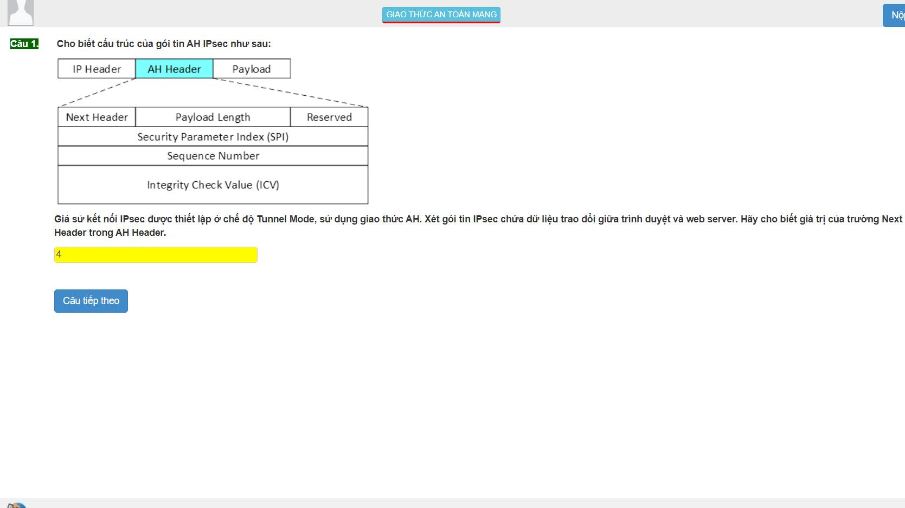

1:4

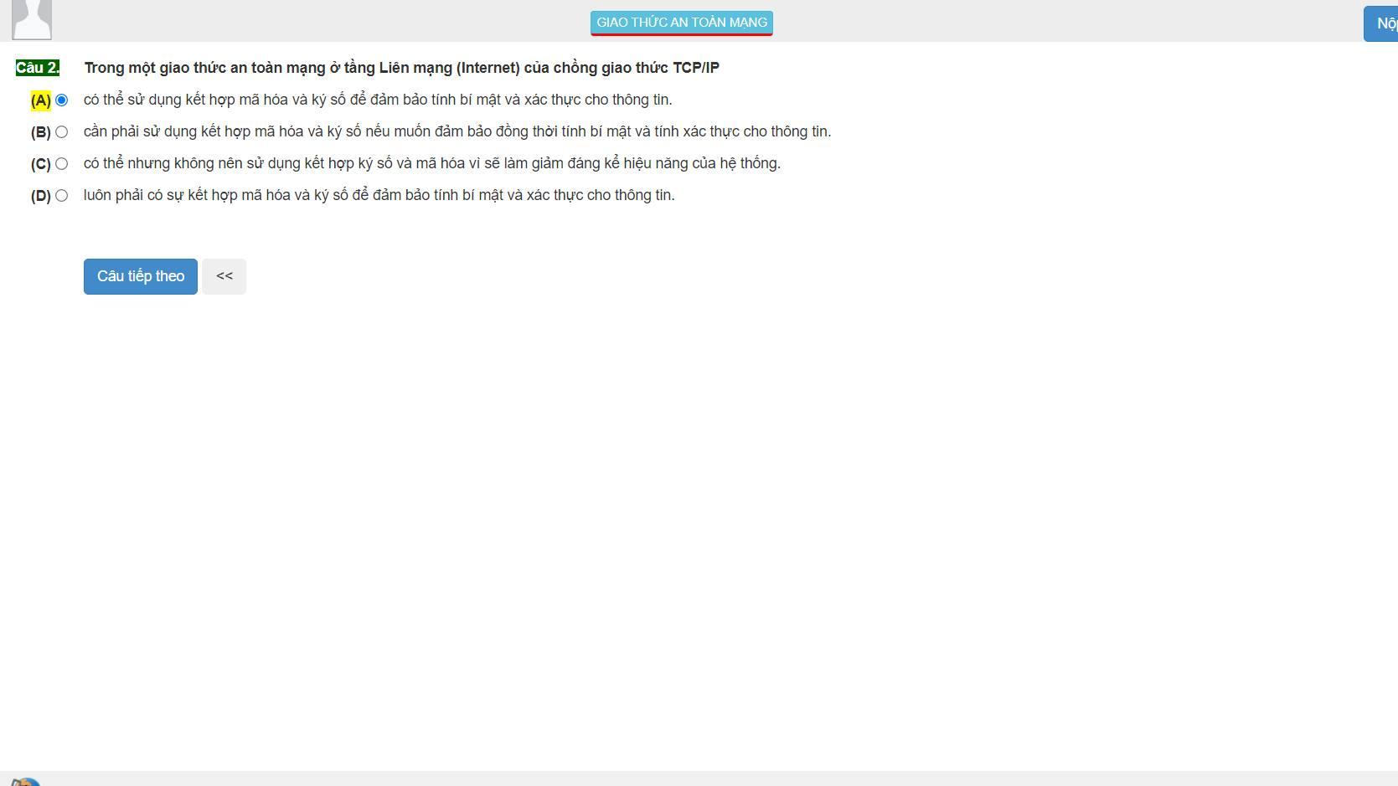

2:A

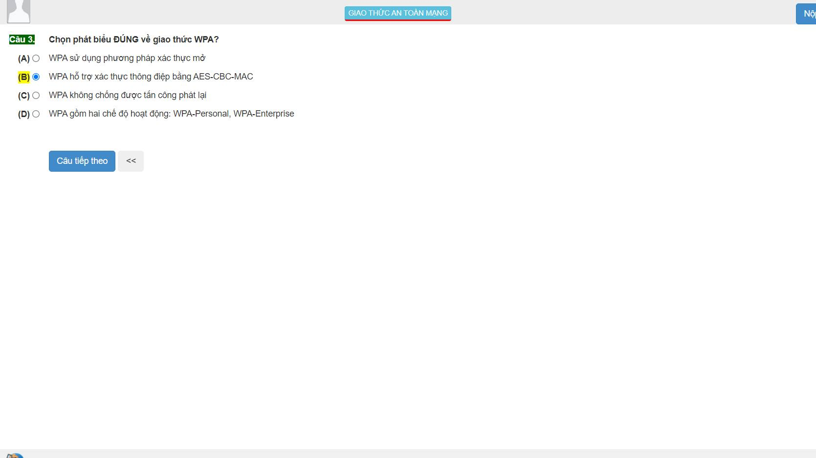

3:D

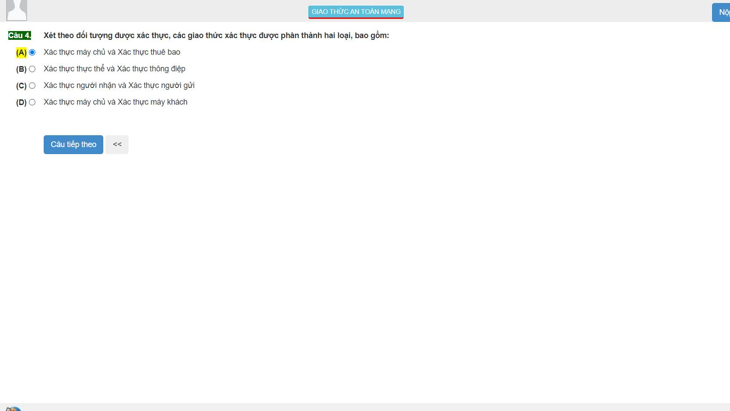

4:B

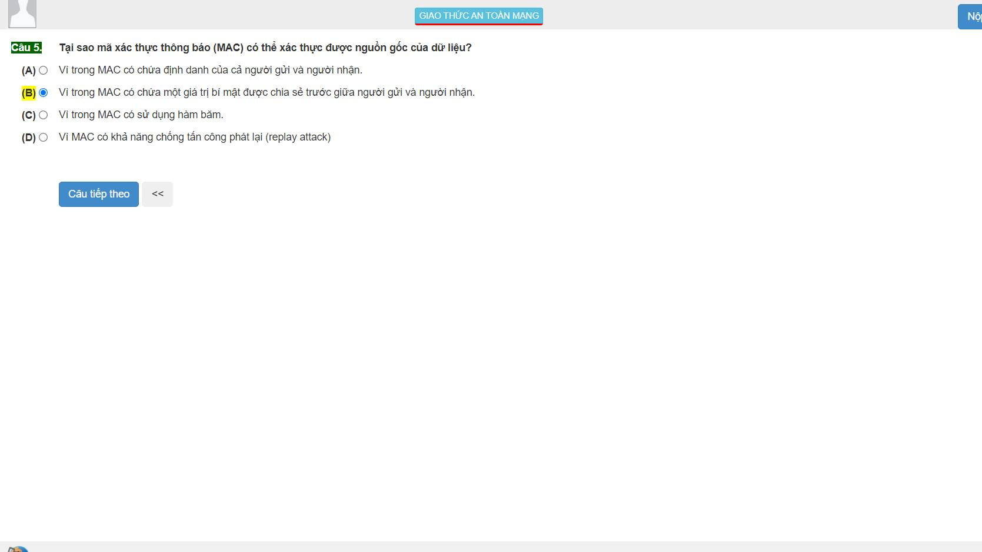

5:B

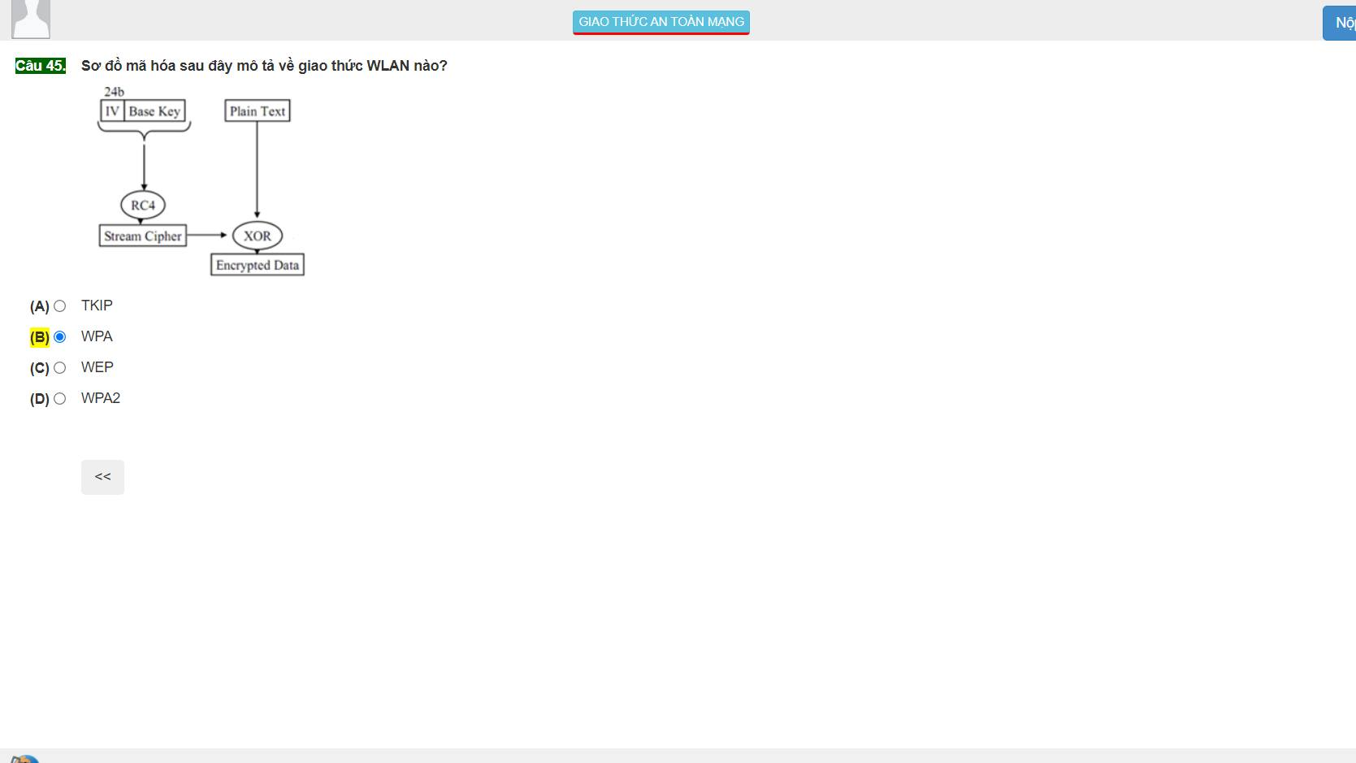

45:C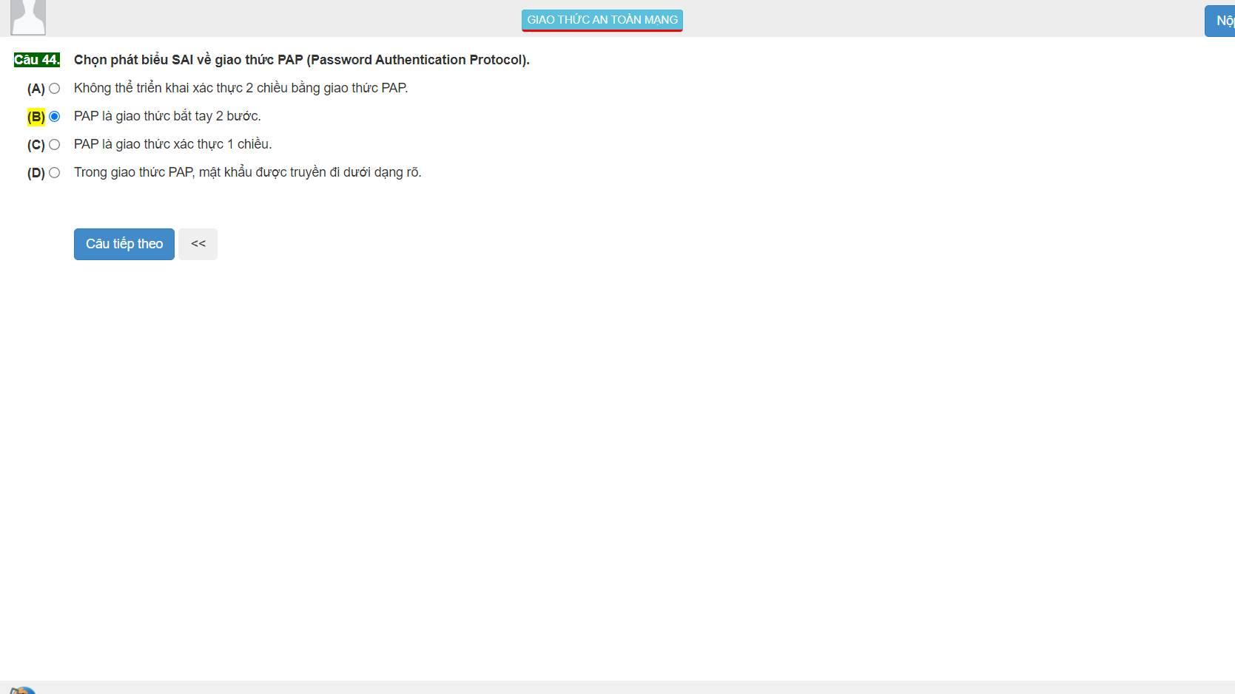

44:A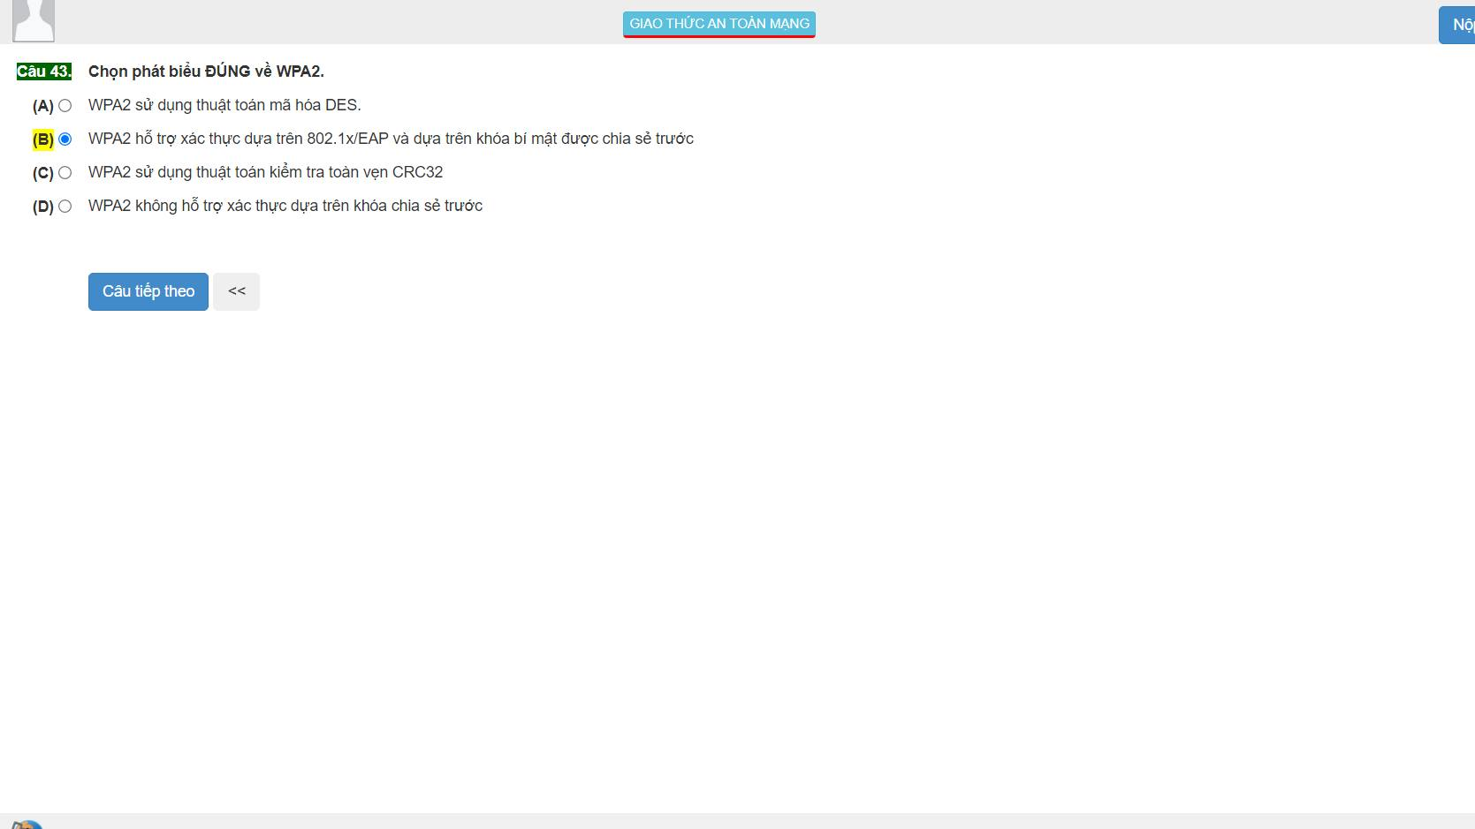

43:B

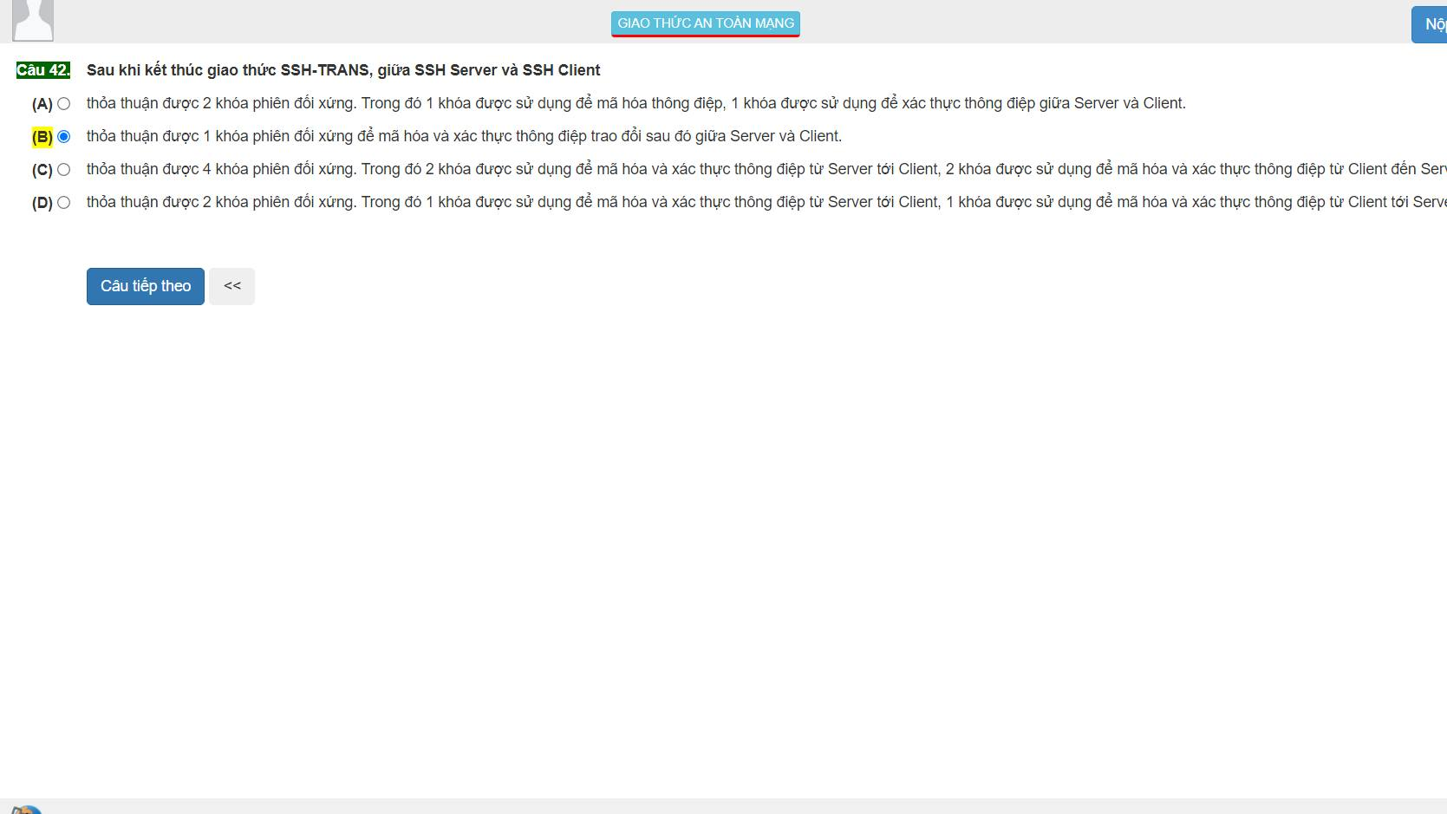

42:C

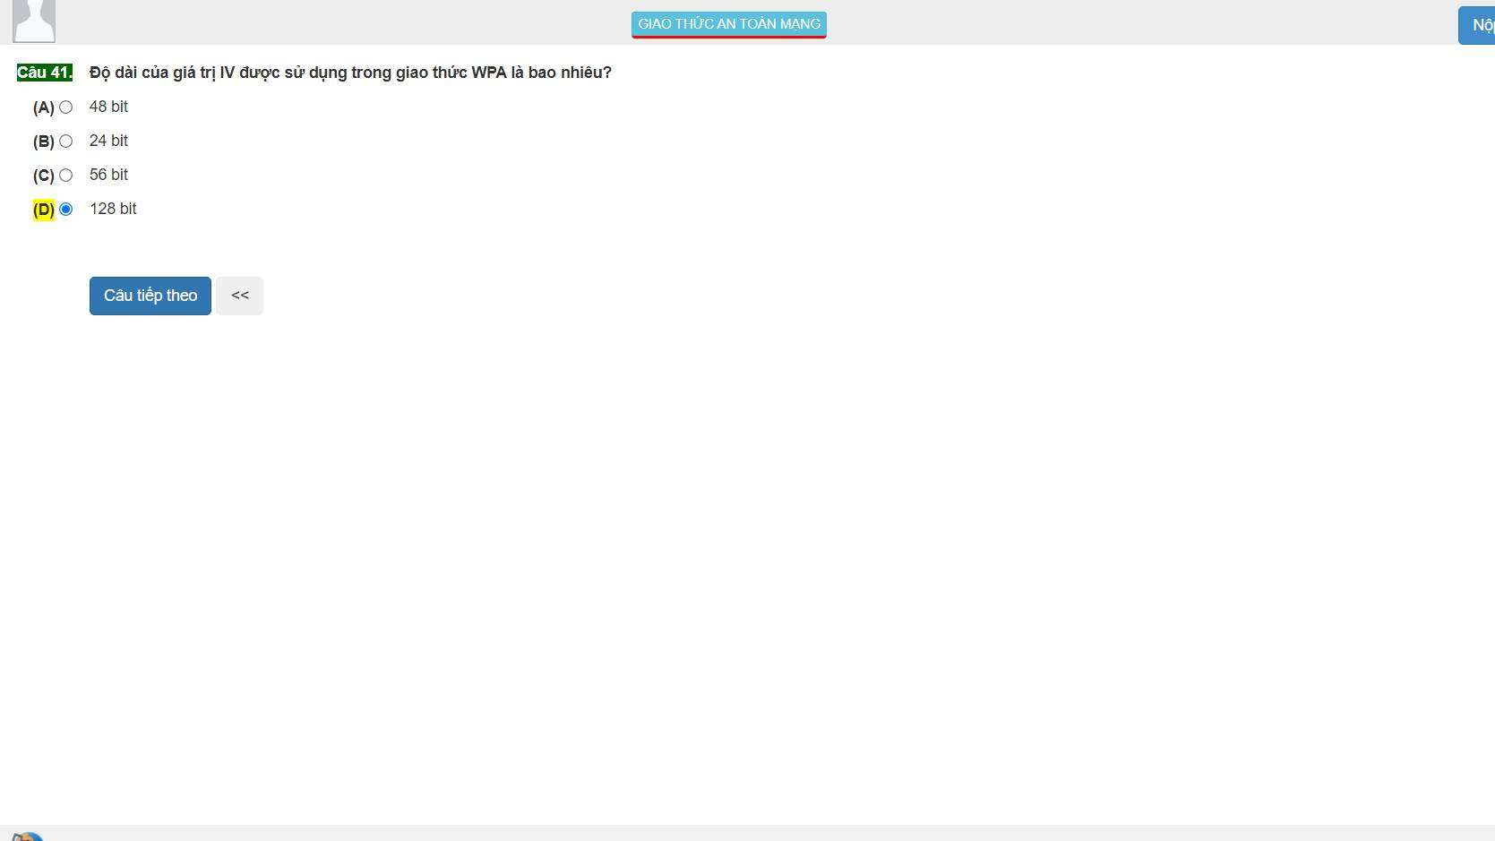

41:A WPA:48bit

WEP:24

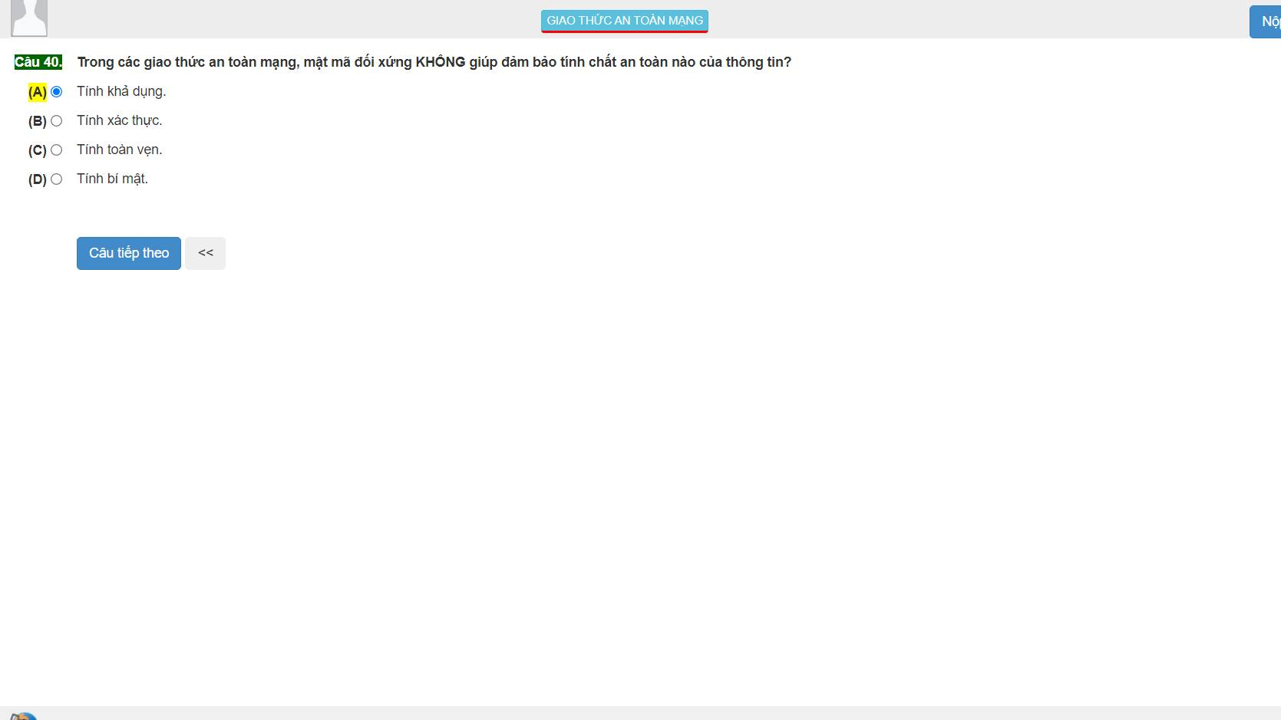40:A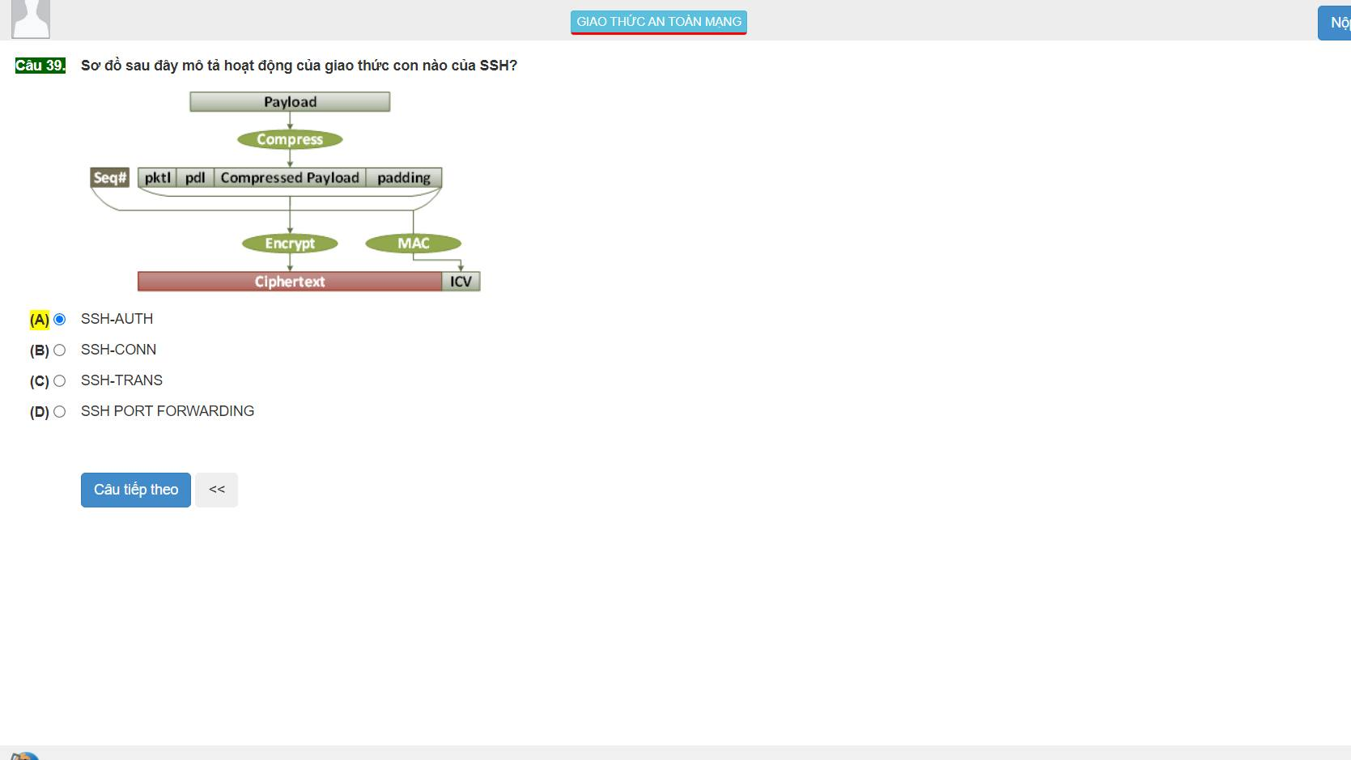

39:C

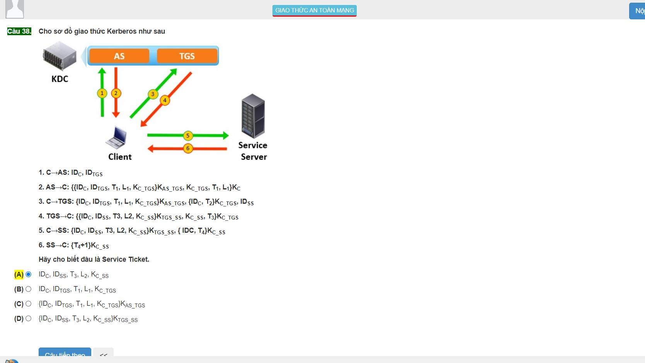

38:A

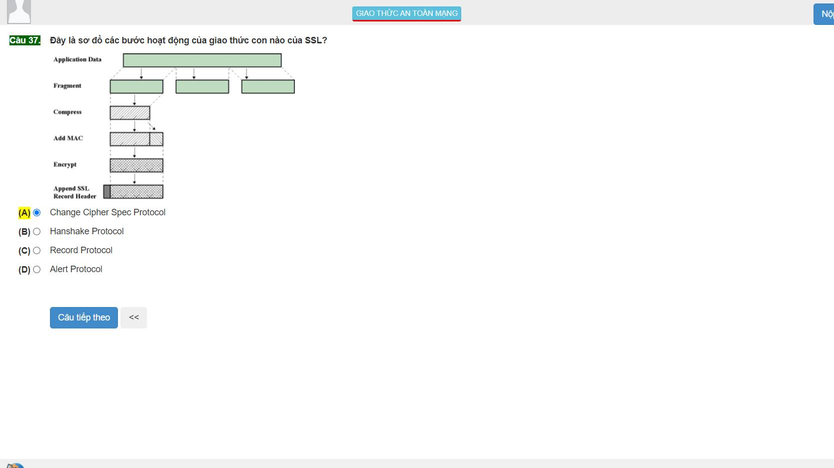

37:C

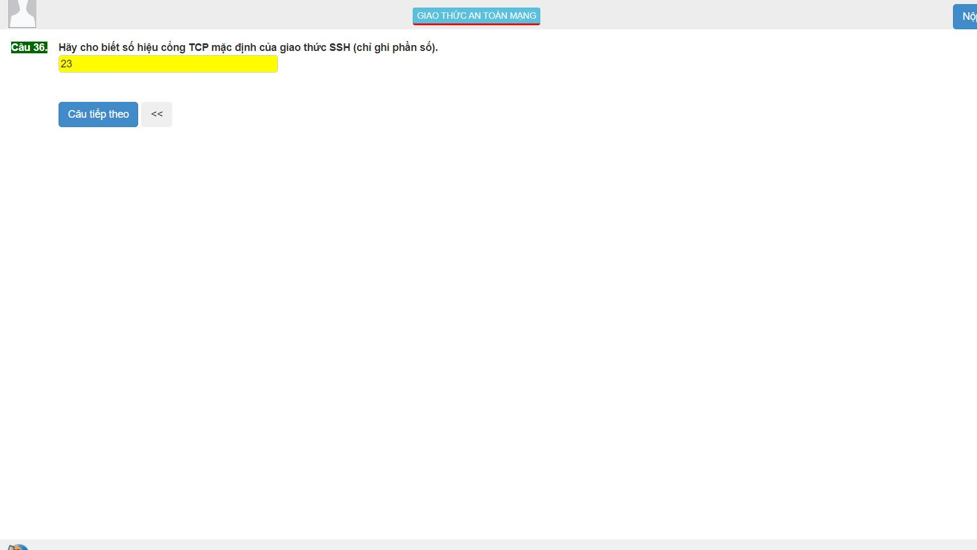

36: SSH:22 Telnet:23

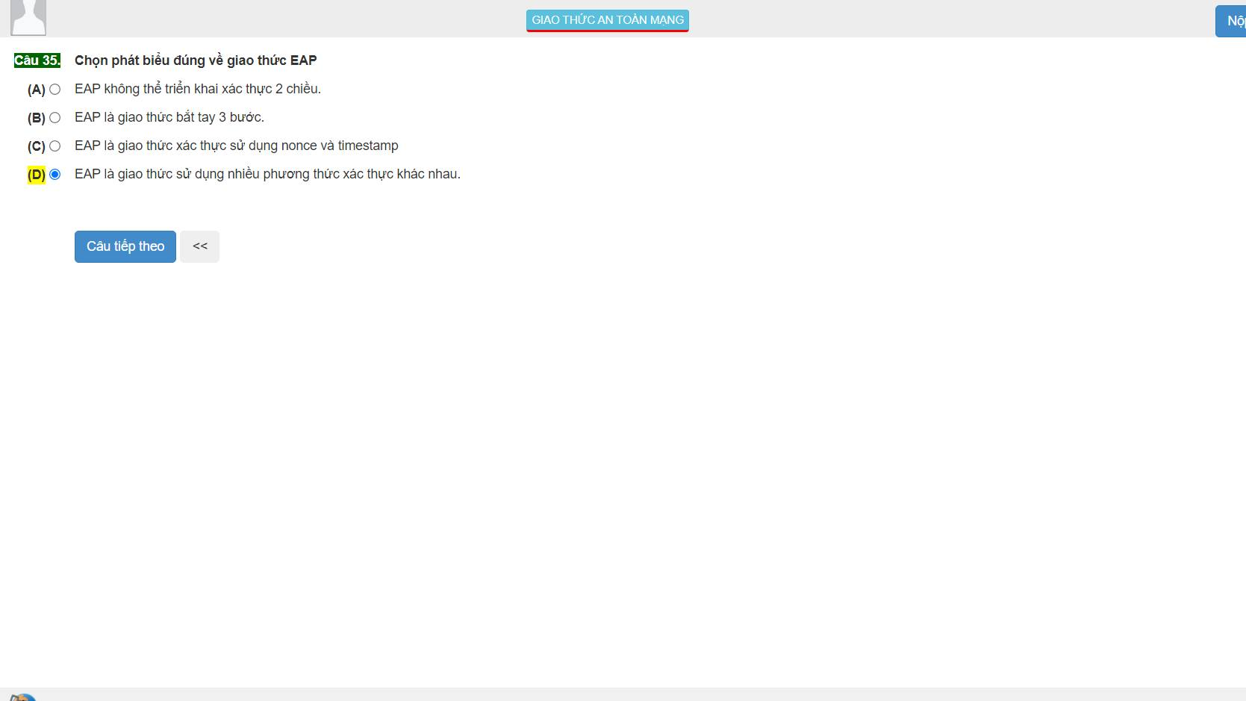

35:D 40 phương thức

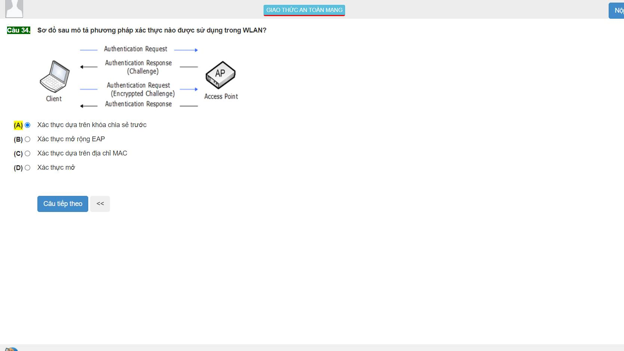

34:A

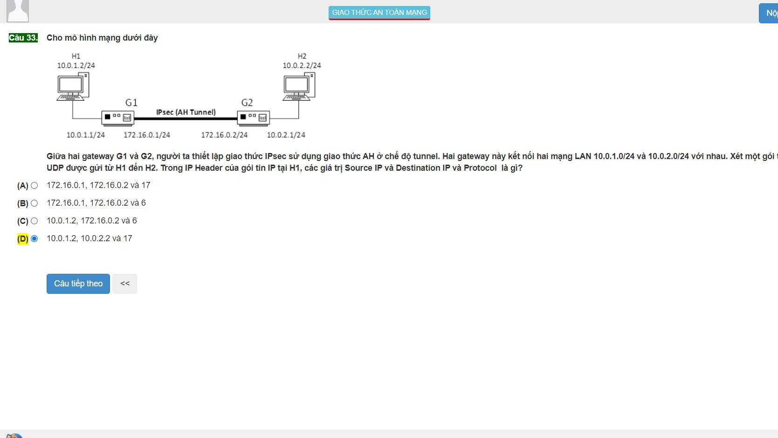

33:A next header =4 :tunnel

6: TCP

17:UDP transport

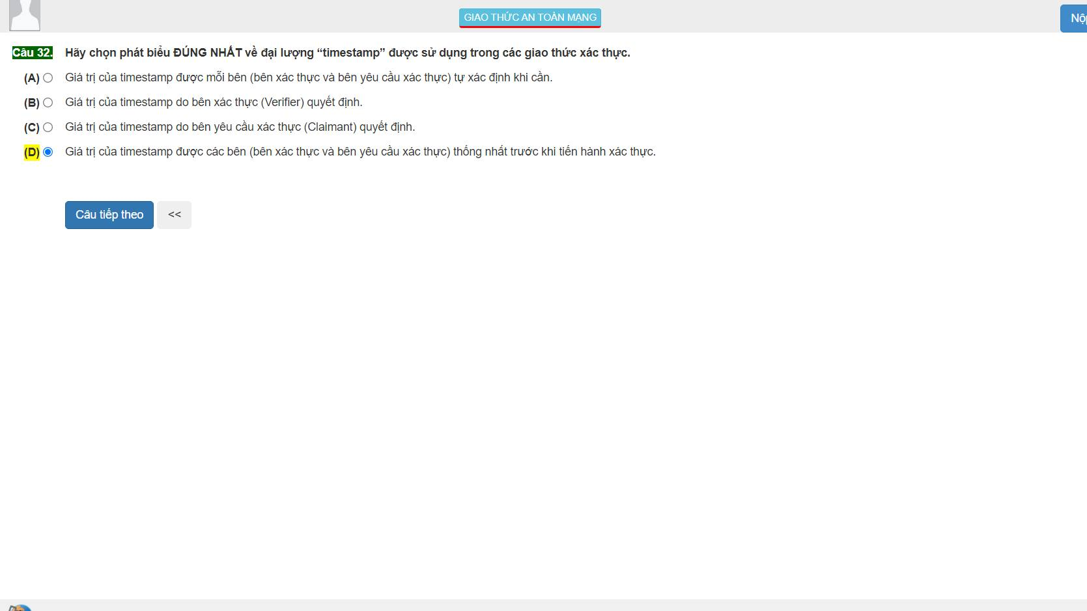

32:D

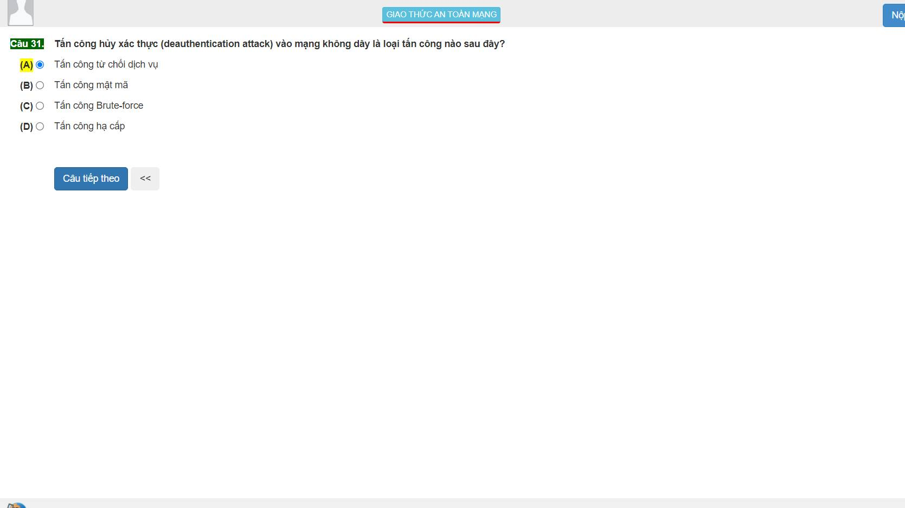

31:A

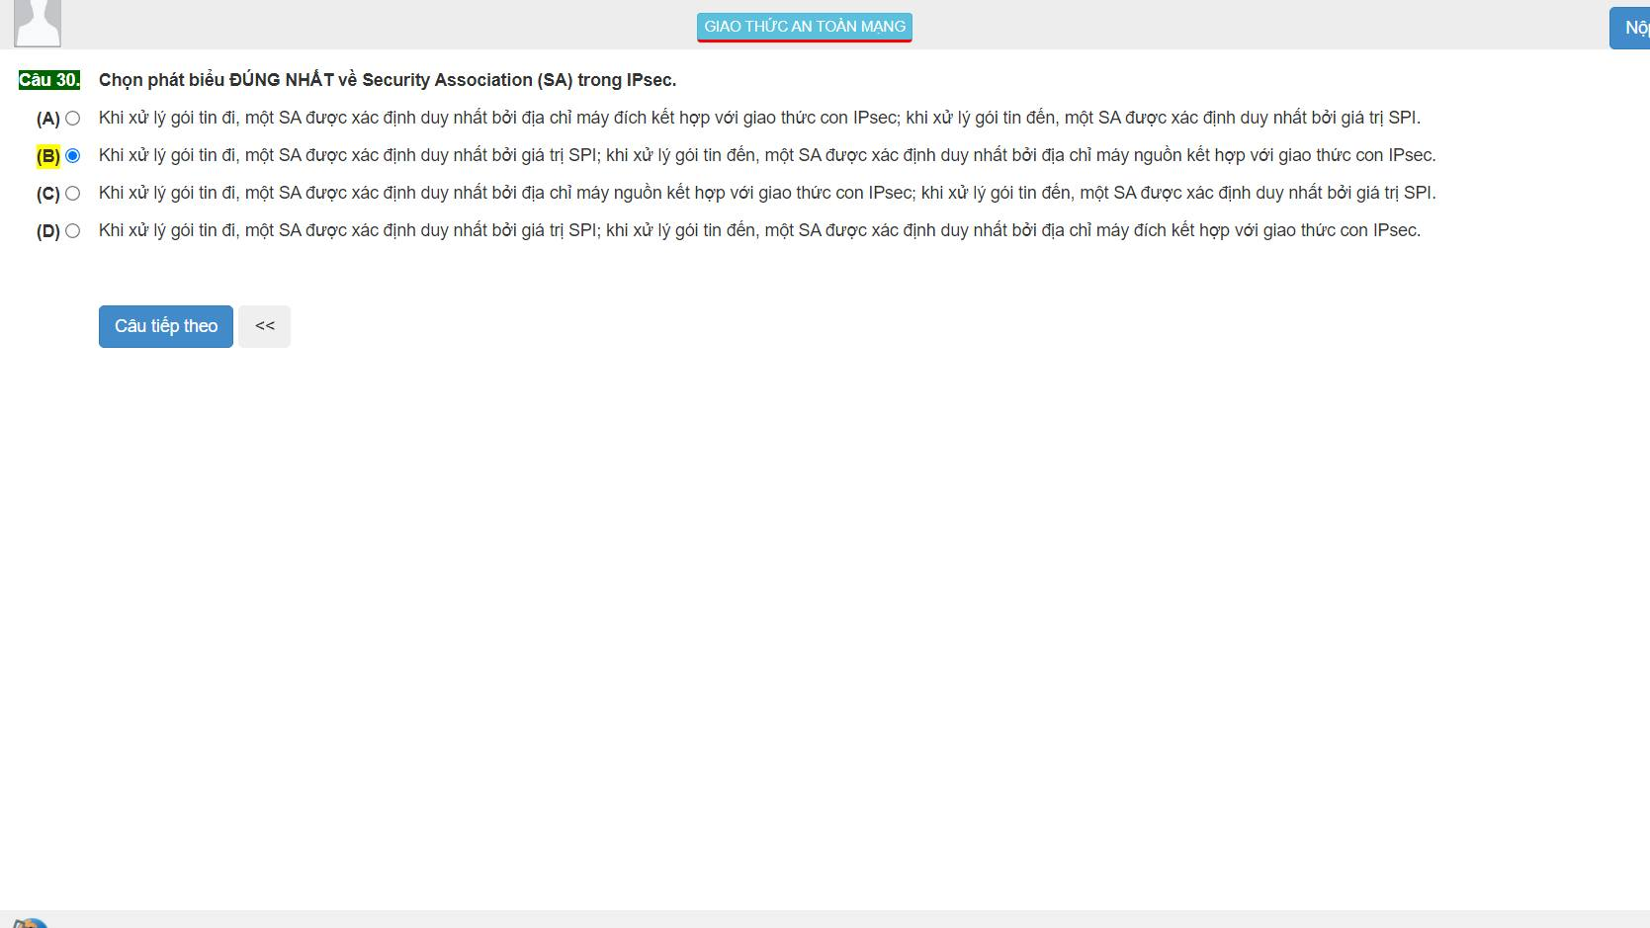

30:D

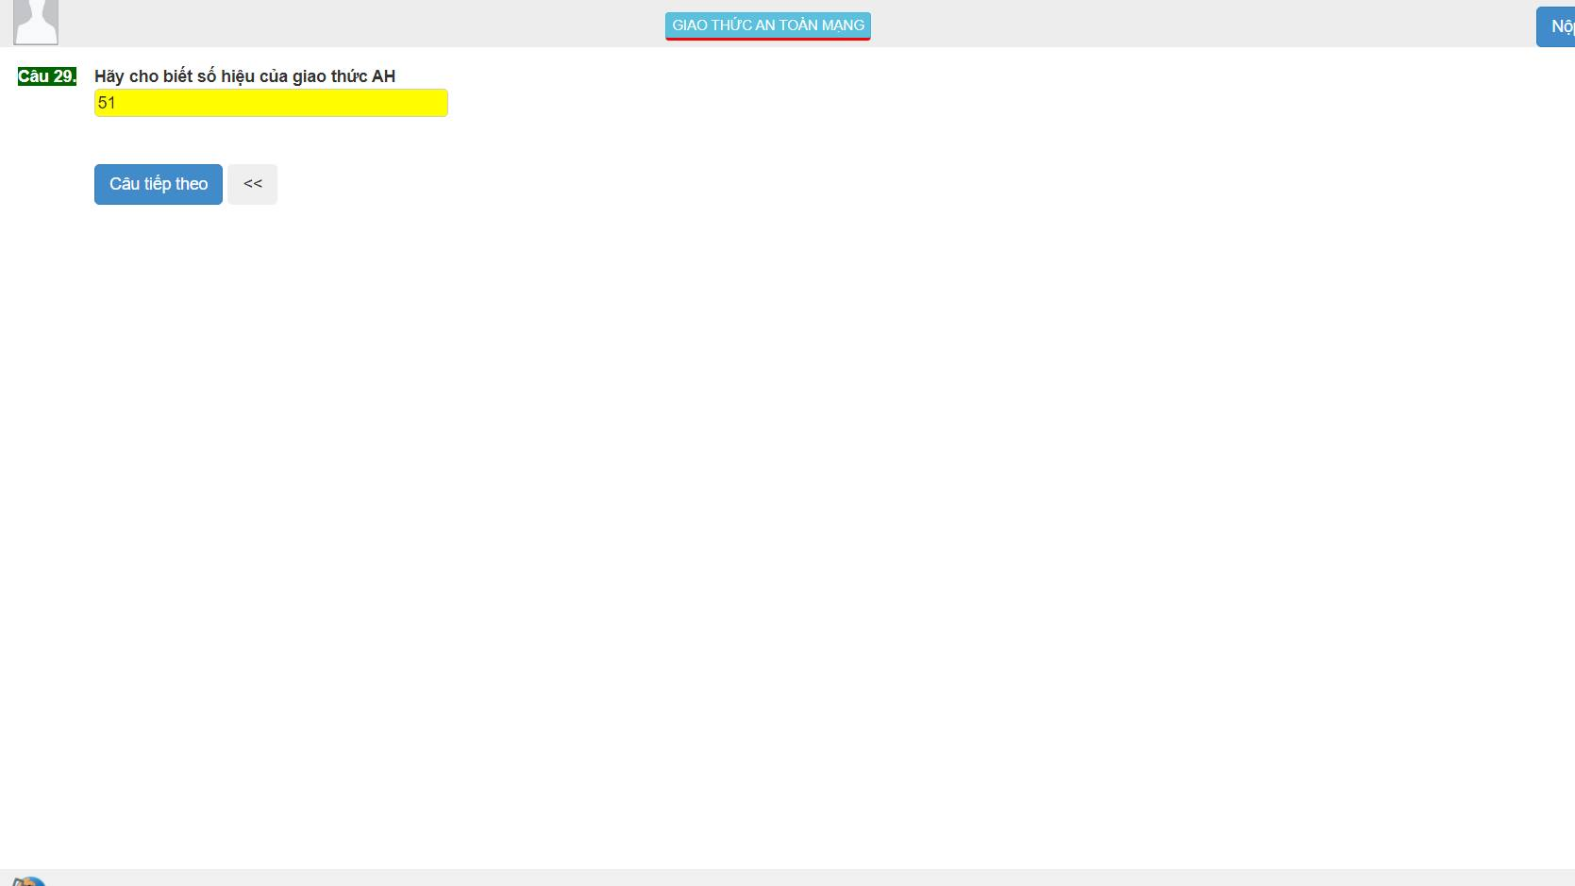

29: AH: 51 ESP:50

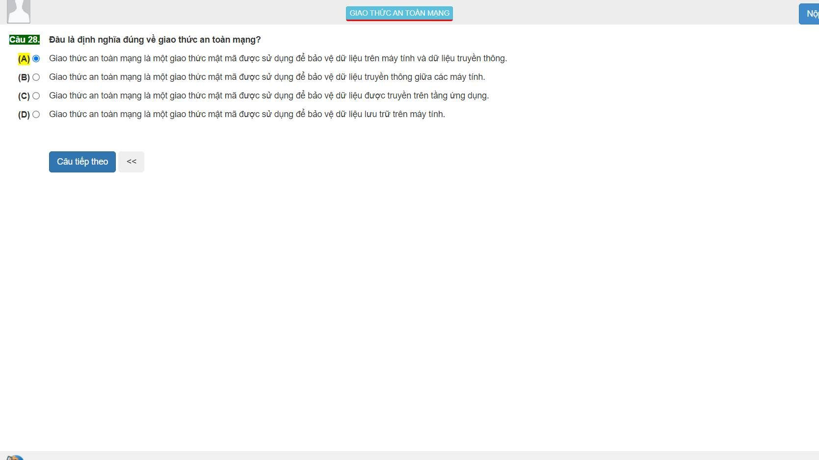

28:A

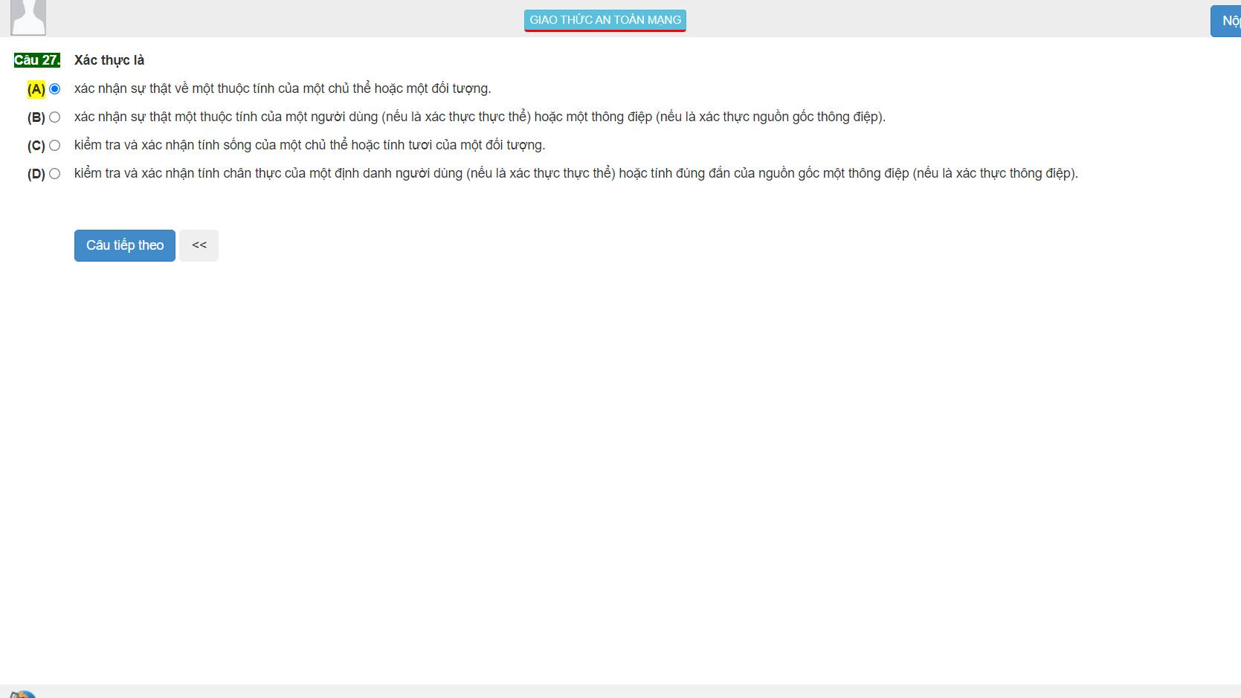

27:A

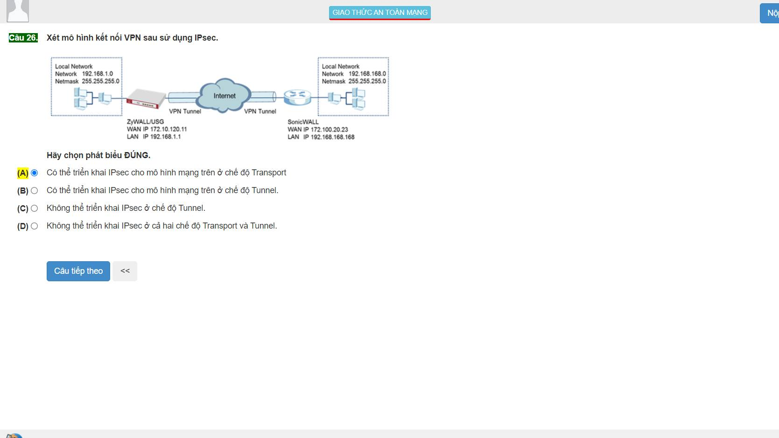

26:B

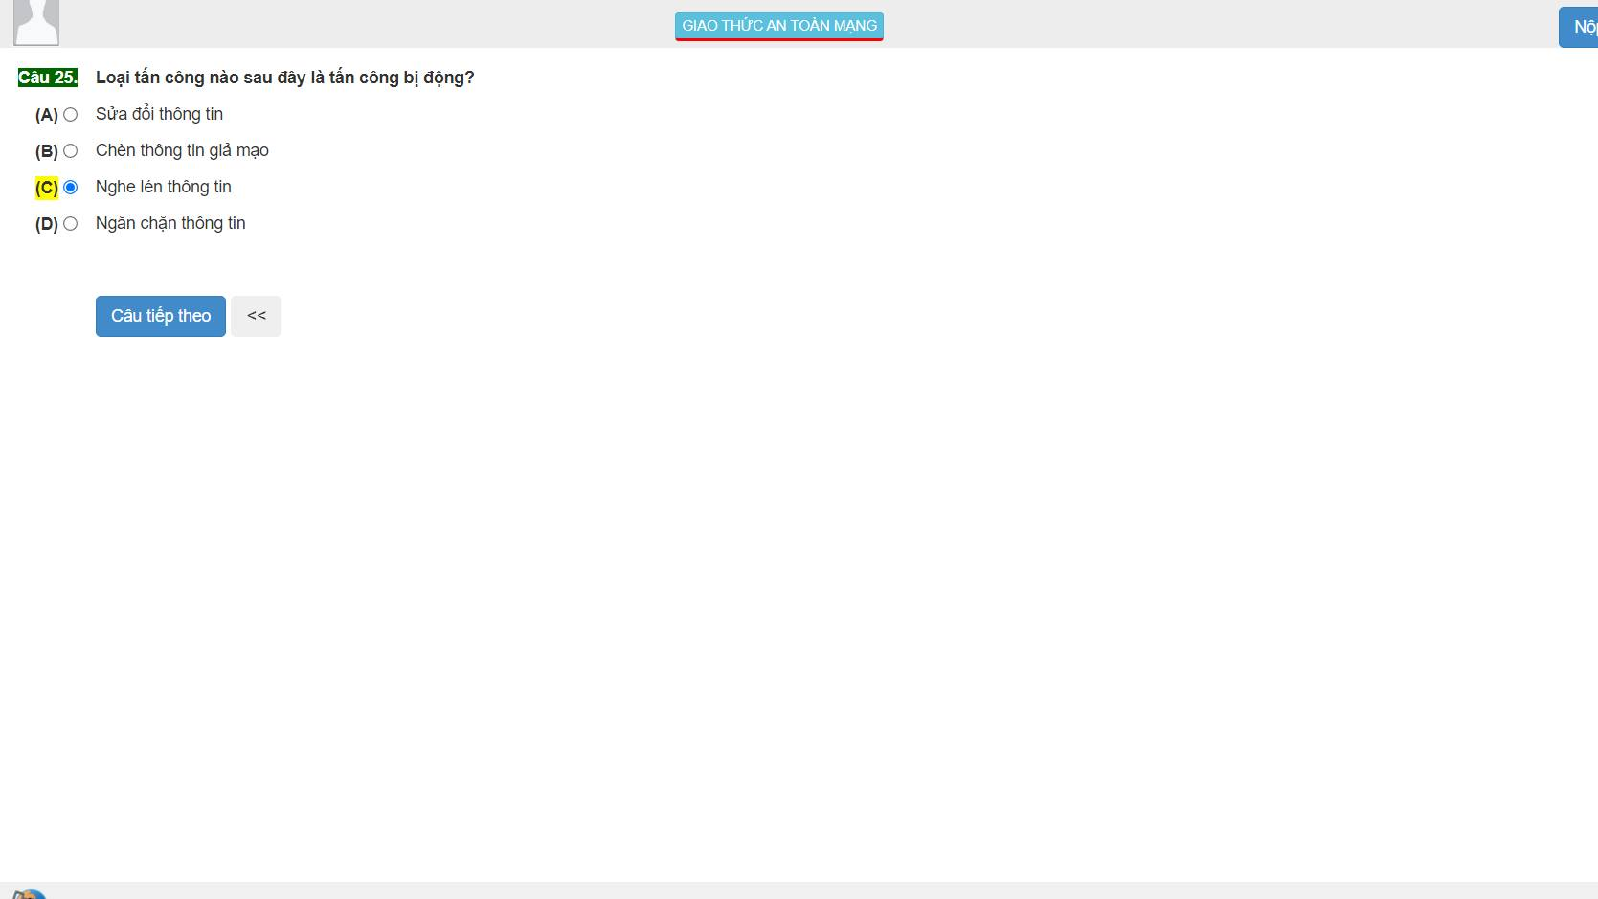

25:C (gián tiếp)

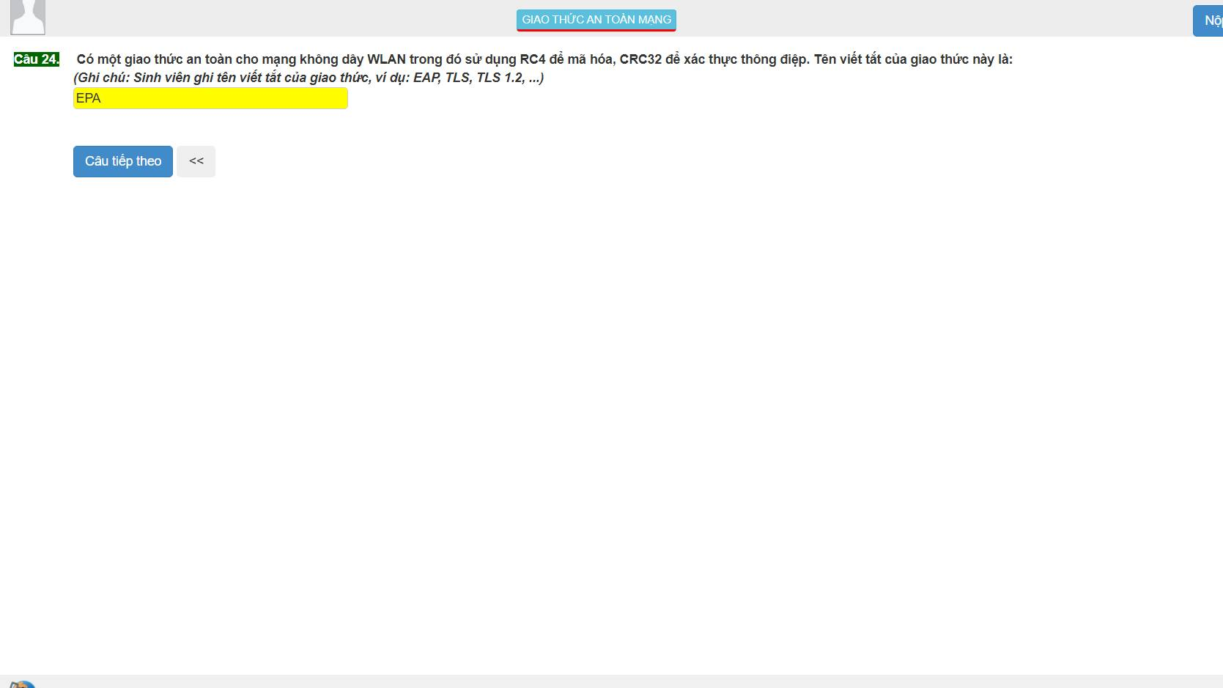

24:WEP : crc32

WPA: michael (64bit)

WPA2: CCMP

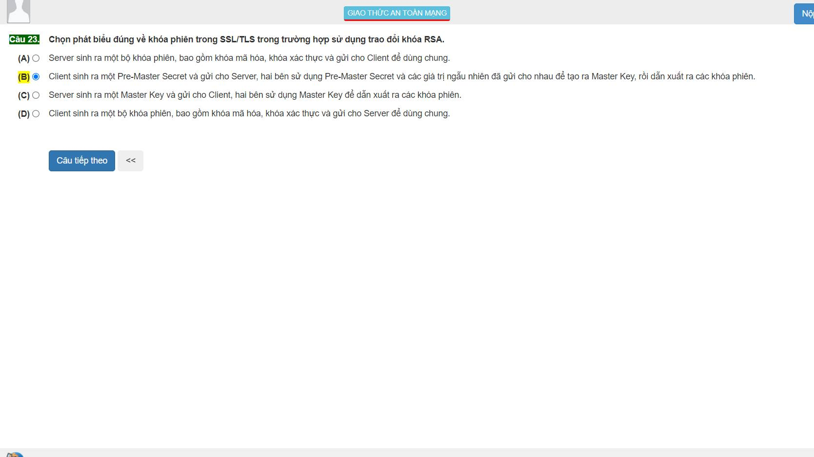

23:B :pre-master secret

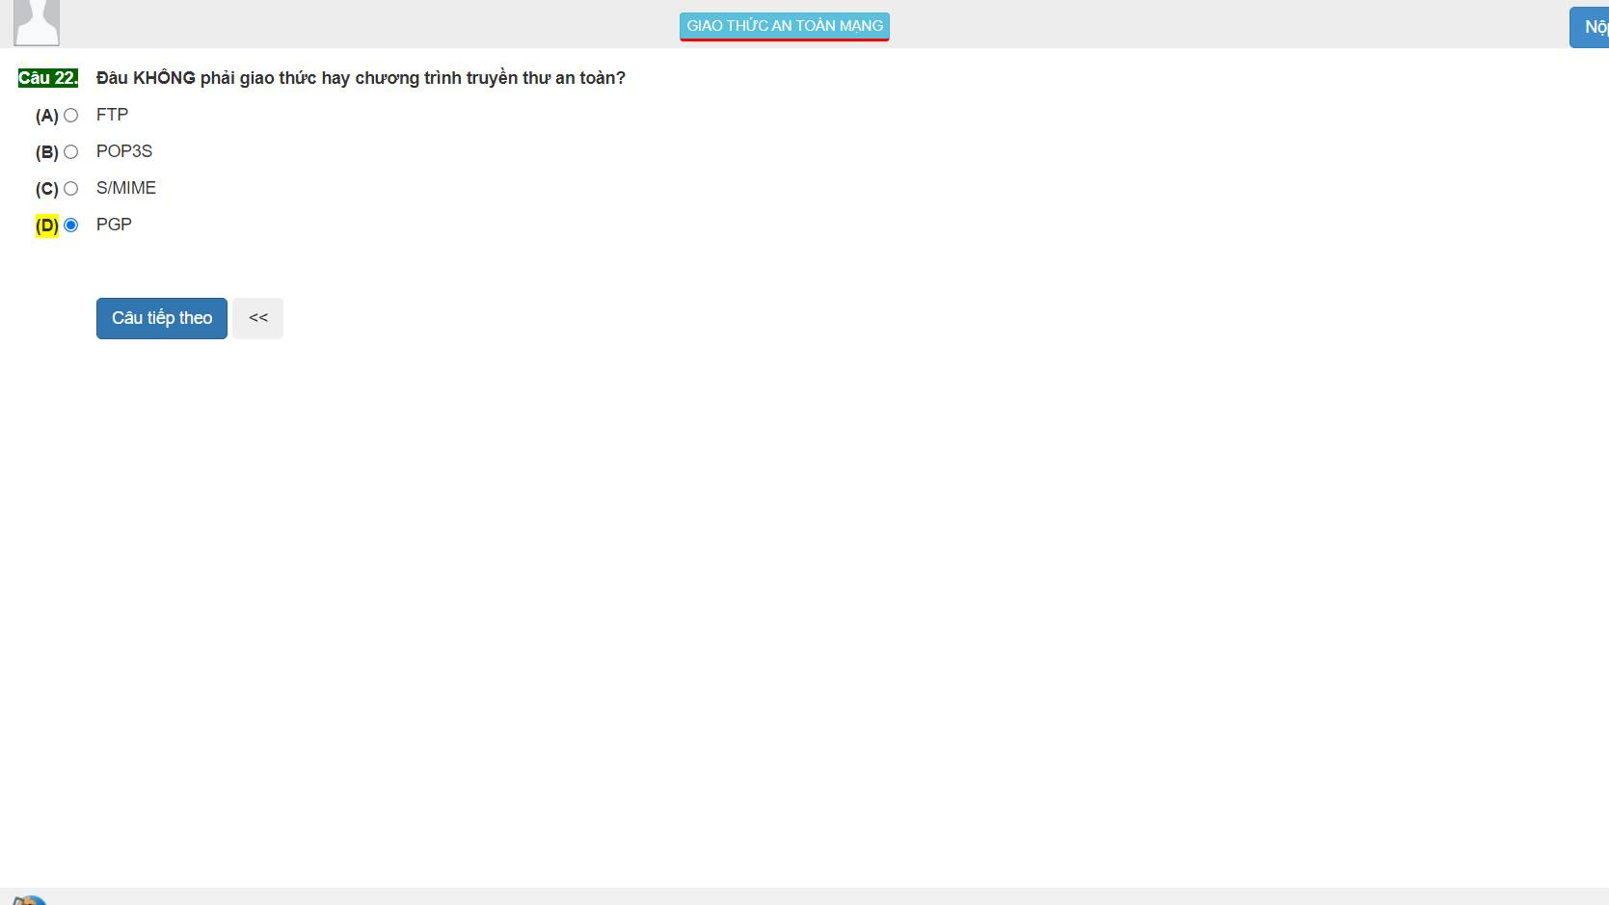

22: FTP, SMTP

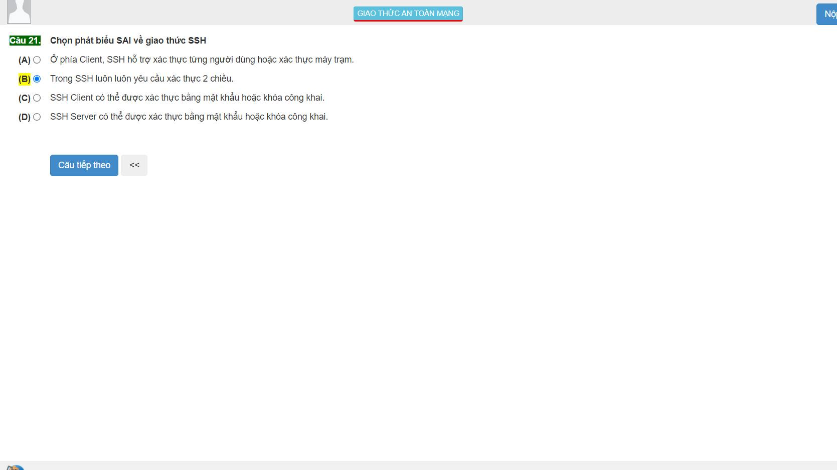

21:D ssh server: public key

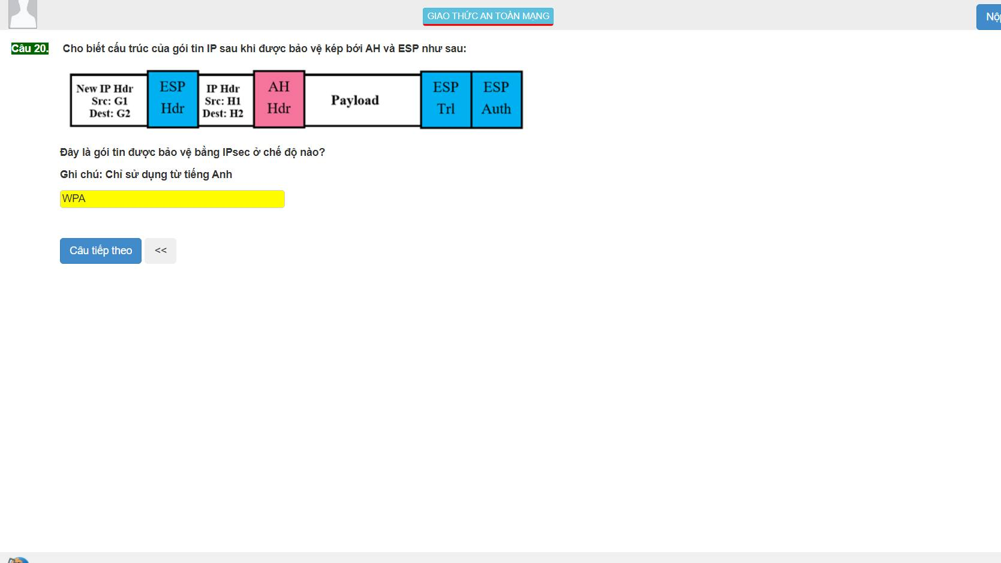

20: tunnel

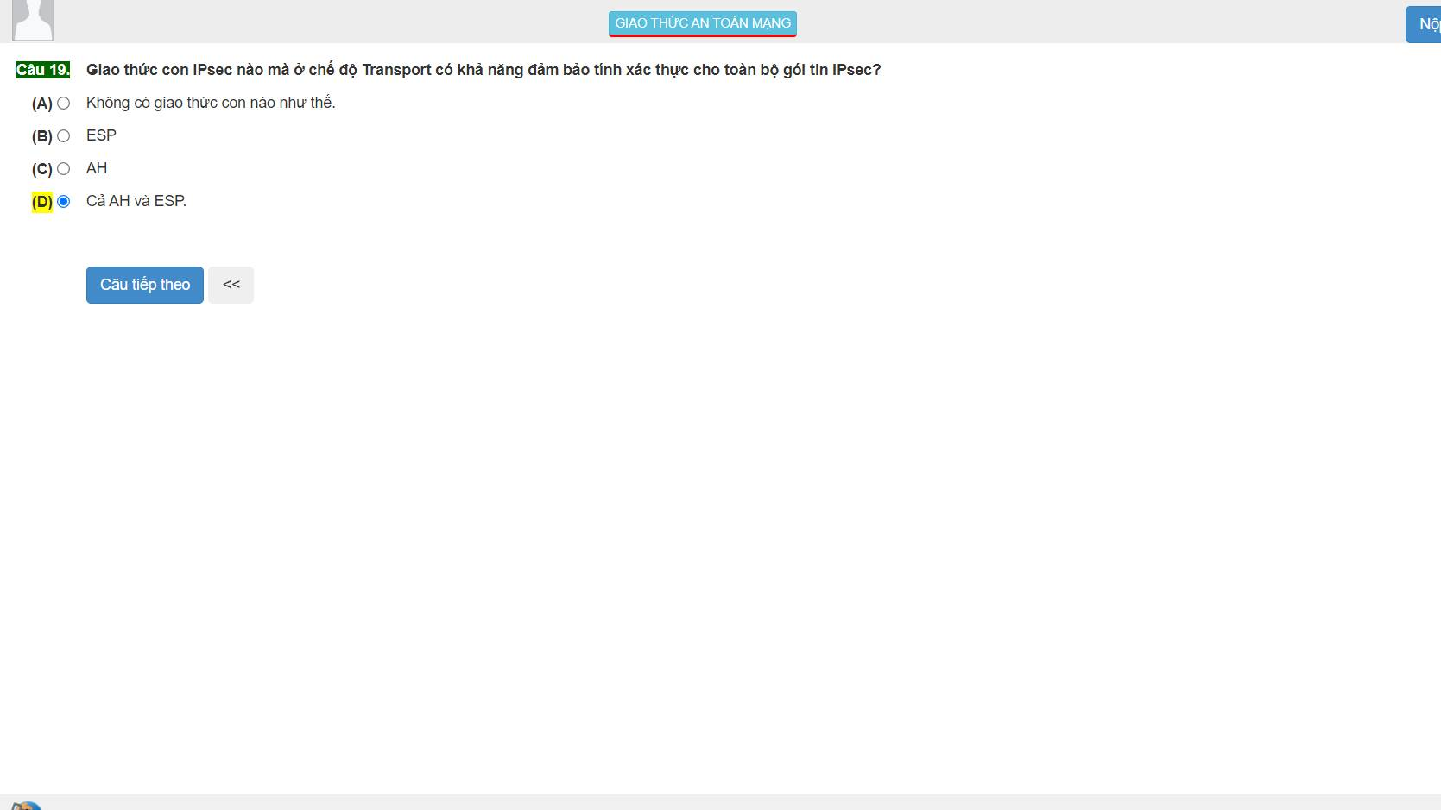

19: AH : xác thức toàn bộ gói tin

ESP: đóng gói tải an toàn

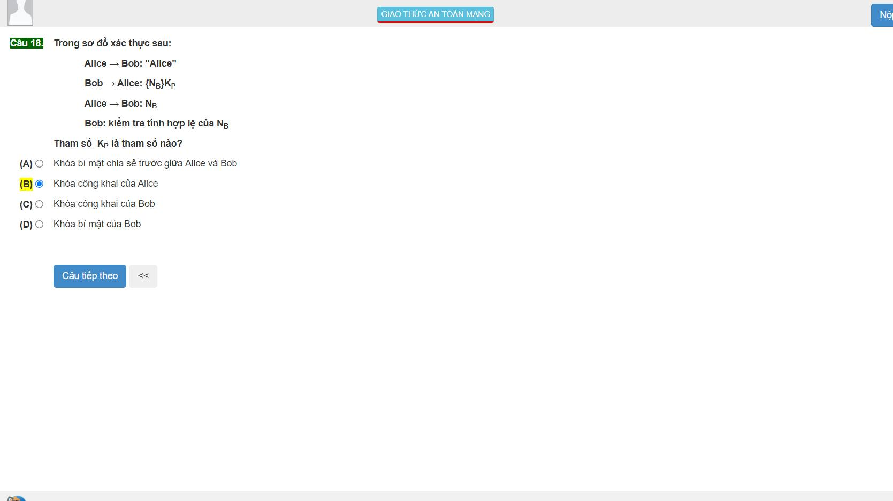

18: B

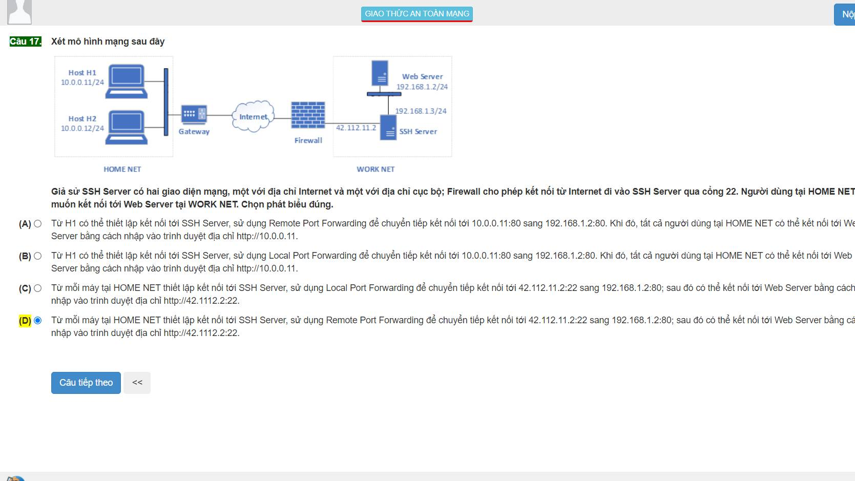

17:D home net – remote port forwarding

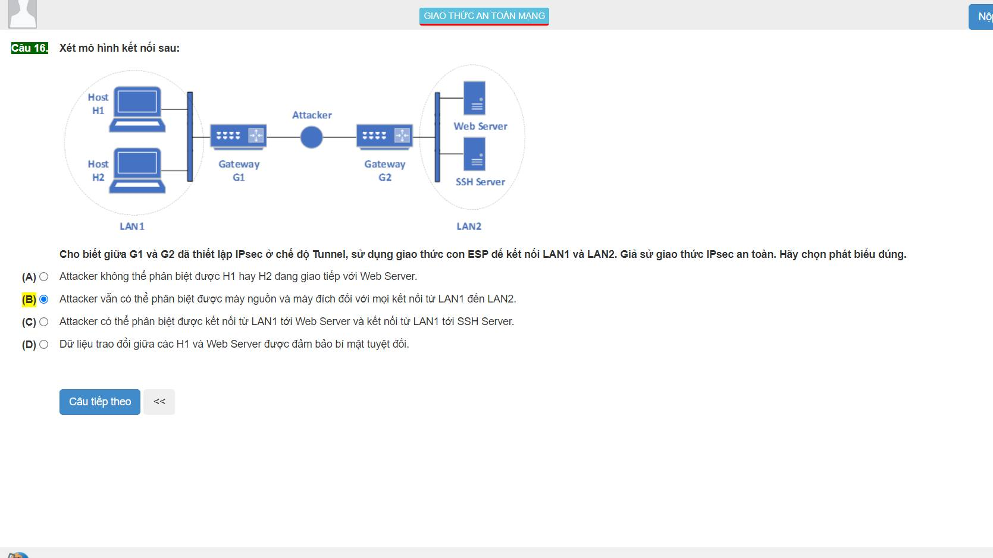

16:A

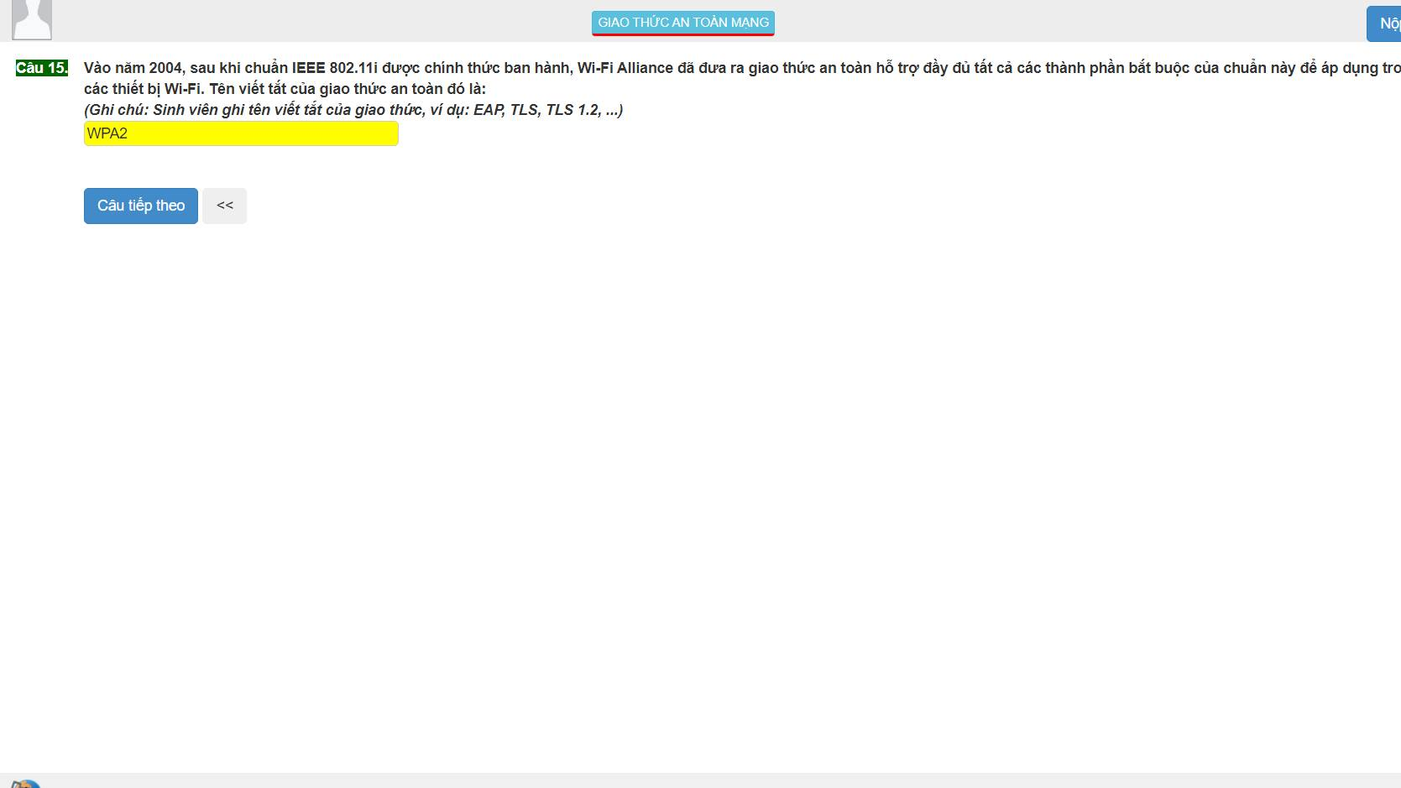

15 : WPA2 : 2004 WPA: 2003 WEP: 1997 WPA3:2018

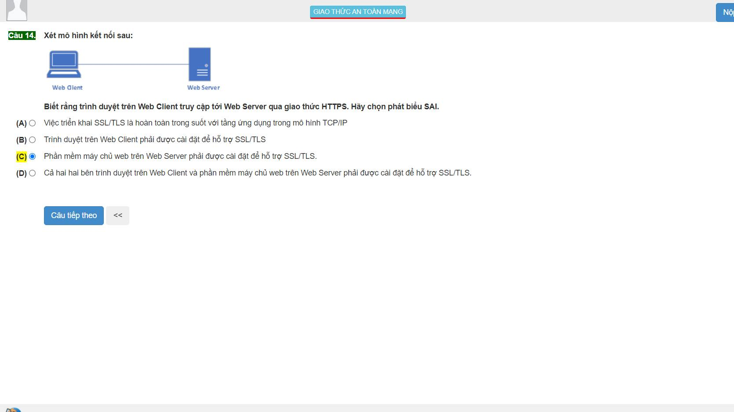

14:A

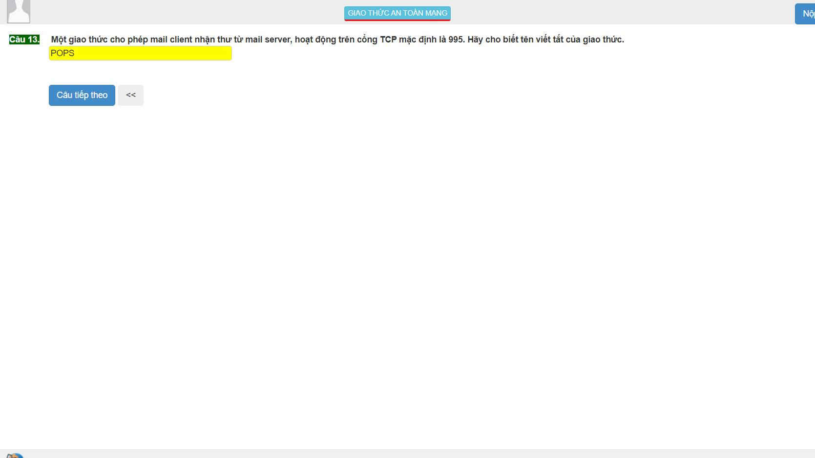

13: POP3S : 995 IMAPS: 993 SMTPS: 465

POP3: 110 IMAP: 143 SMTP: 25

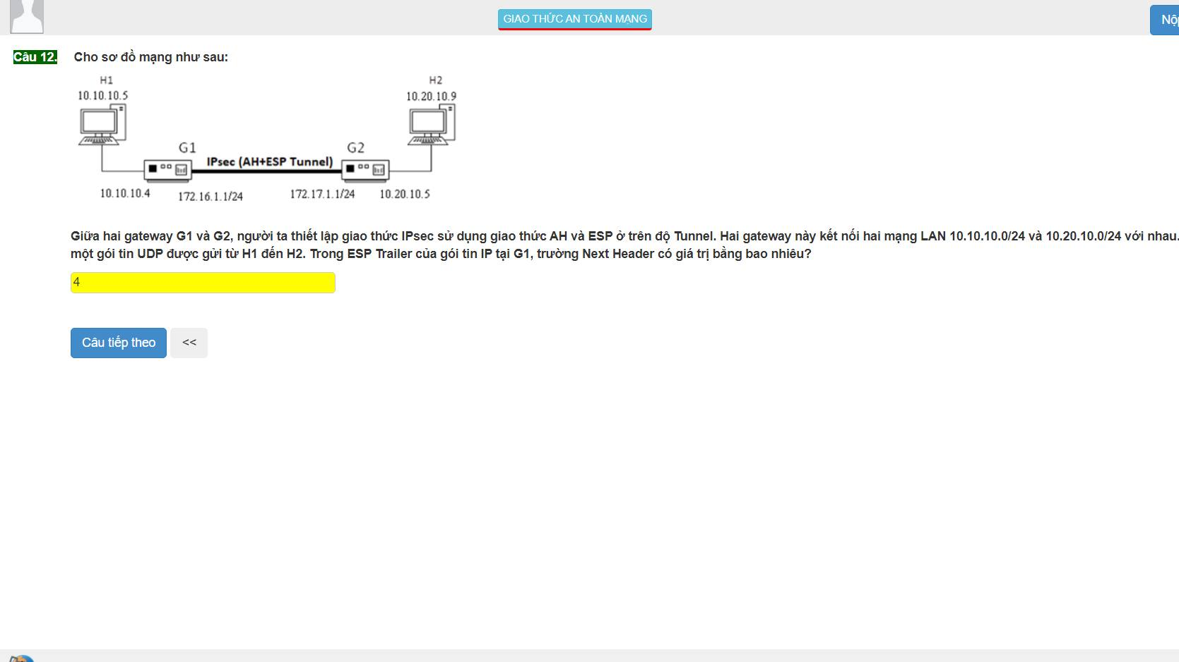

12: 4

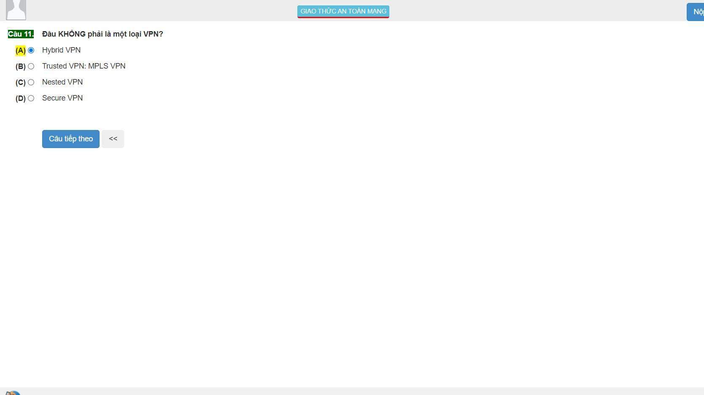

11:C

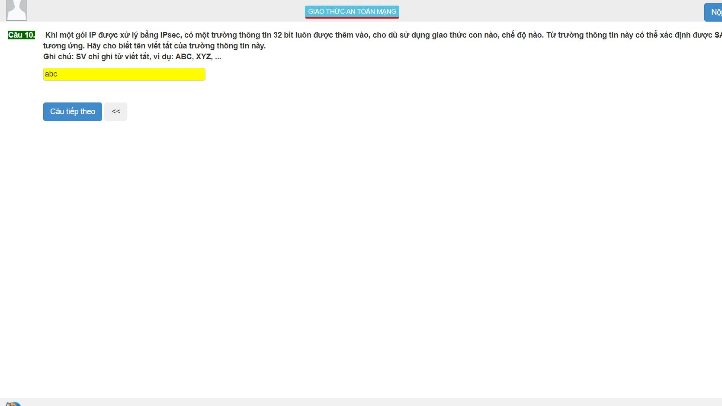

10:SPI ipsec: SPI: 32

ICV: 96 bit

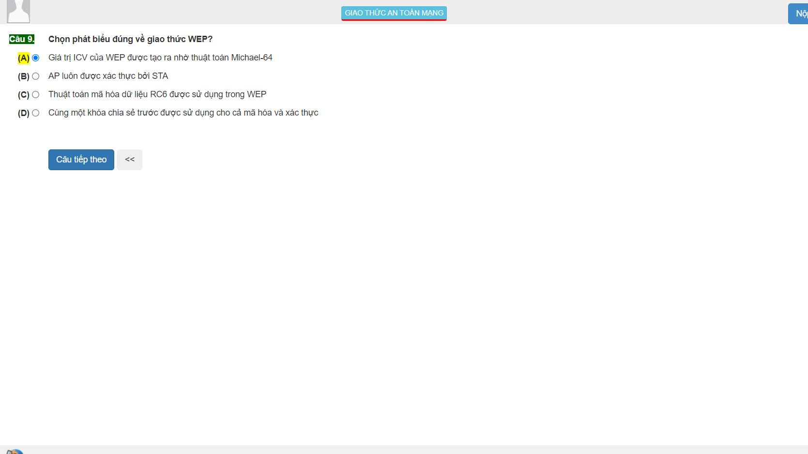

9:D

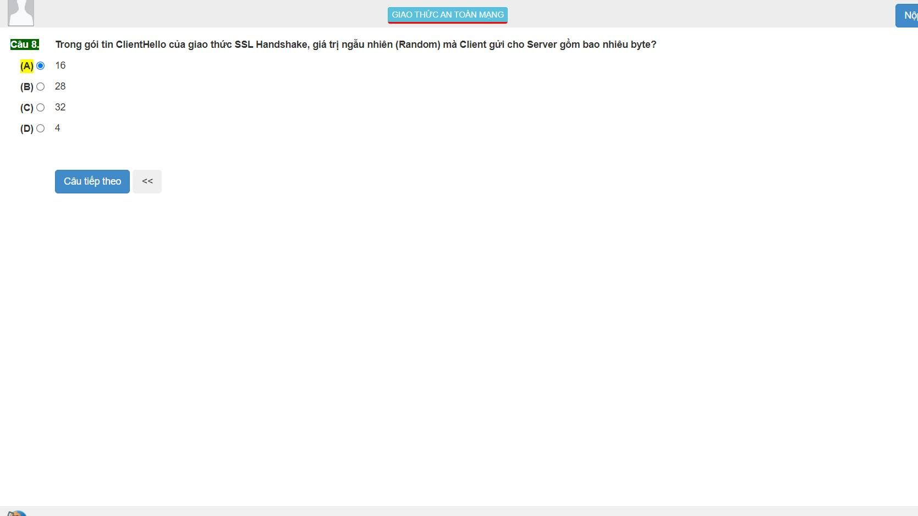

8: C 32 bit

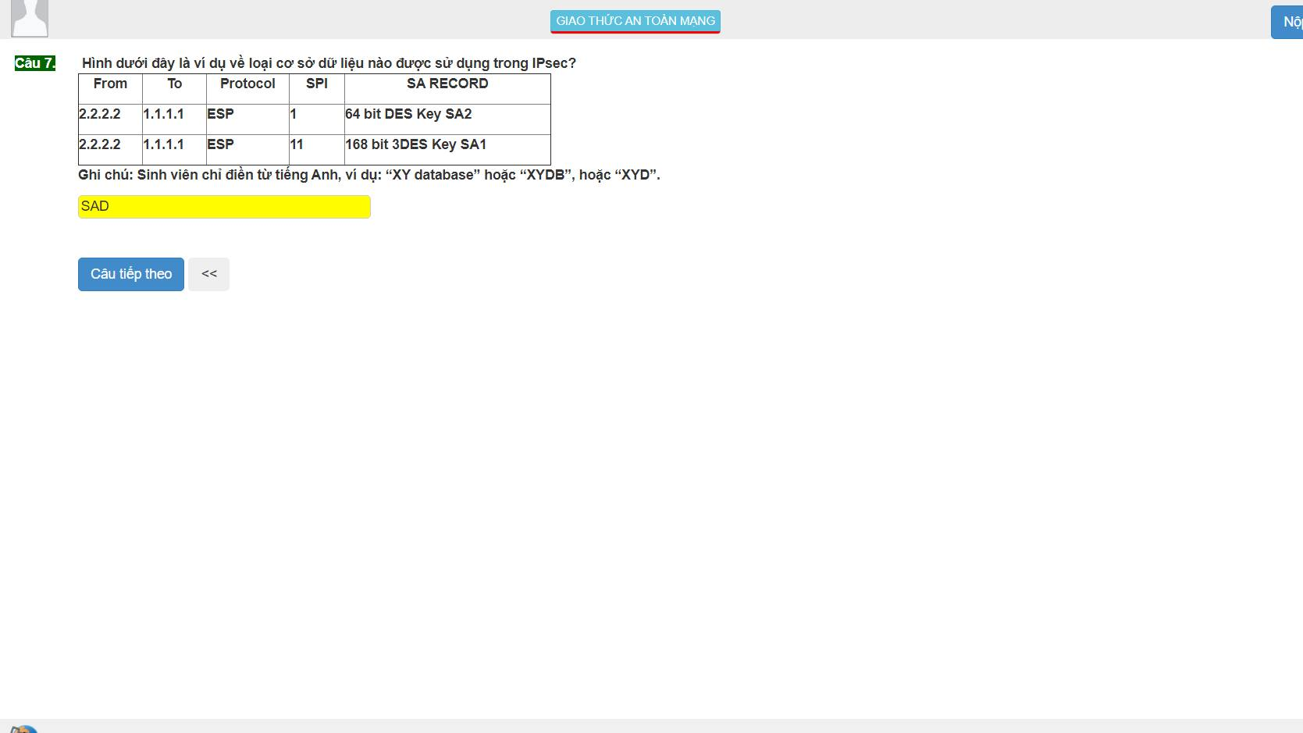

7: SAD: tổ hợp an toàn

SPD: chính sách an toàn

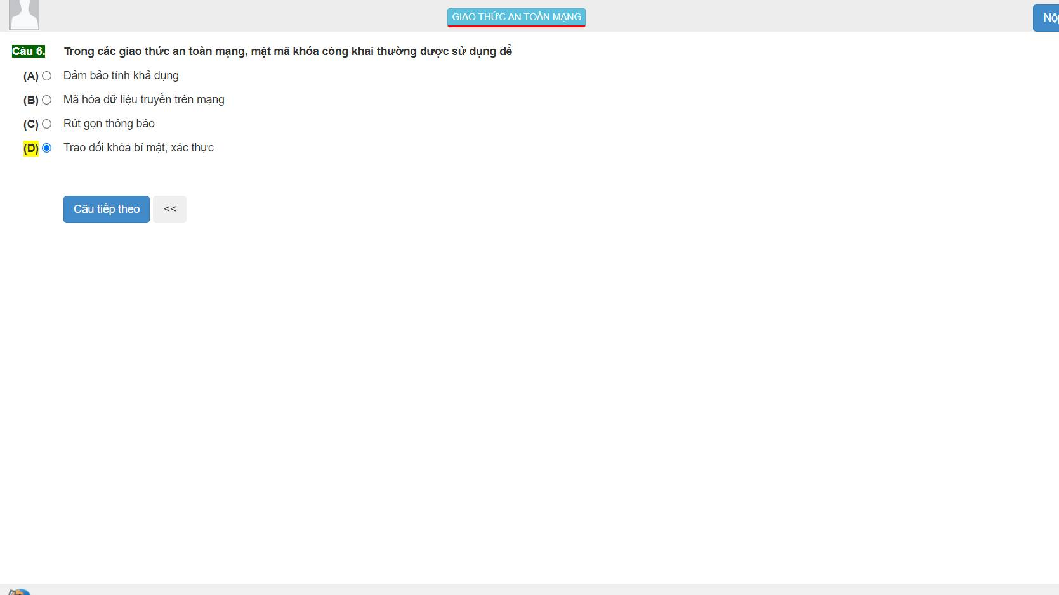

6: B

|  |  |  |  |  |
| --- | --- | --- | --- | --- |
| 1. 4 2. A 3. D 4. B 5. B 6. B 7. Sad 8. C 9. D 10. Spi 11. C 12. 4 | 1. Pop3s 2. A 3. Wpa2 4. A 5. D 6. B 7. C 8. Tunnel 9. D 10. A 11. B 12. Wep | 1. C 2. B 3. A 4. A 5. 51 6. D 7. A 8. D 9. A (NH=4) 10. A 11. D 12. 22 | 1. c 2. A 3. C 4. A 5. A 6. C 7. B 8. A 9. C |  |